Aaron Panicker
B00158358

Deep Neural Networks in Tensorflow and Keras
Computer Vision Assignment 2

Contents
1. Introduction 2
2. Question 1 How Long Did the Network Take to Train? 2
3. Question 2 Is the Dataset Balanced? 3
4. Question 3 Is the Network Overfitting? 4
5. Question 4 Can Data Augmentation Be Performed? 5
6. Question 5 What Layers Are in the Network and Can It Be Improved? 5
6.1 Baseline Network Layers 5
6.2 Keras Tuner 6
7. Question 6 Is Transfer Learning an Option? 6
7.1 Phase 1 Frozen Layers 6
7.2 Phase 2 Fine-Tuning 7
8. Question 7 Precision, Recall and F1 Scores 7
8.1 What These Metrics Mean 7
8.2 Results 8
8.3 Which Metric Is Best? 9
9. Question 8 How Can the Model Be Better at Finding Sick Patients? 9
10. Question 9 Can We See What the CNN Is Looking At? GradCAM 10
11. Question 10 Additional Research 11
11.1 BatchNormalization 11
11.2 Early Stopping 11
11.3 Learning Rate 11
11.4 Increasing Filters 12
12. Conclusion 12

1. Introduction
For this assignment, a chest X-ray classification model was taken and improved as much as possible. The model looks at X-ray images and decides whether they show Bacterial Pneumonia, Viral Pneumonia, or Normal healthy lungs. All the work was done in Google Colab using a T4 GPU. Along the way, different techniques were tried and tested, and this report explains what was done, what worked, what did not, and why.

2. Question 1 How Long Did the Network Take to Train?
The baseline model from the pneumonia_classification.py script was run first to get a starting point. It was trained for 8 epochs with a batch size of 12, using images resized to 128x128 pixels on a T4 GPU in Google Collab.
Training took 5.09 minutes in total, with each epoch taking around 38 seconds on average. This is fast because the GPU can run many calculations at the same time. Without a GPU, the same training would have taken 30 to 60 minutes. Therefore, using the GPU runtime in Collab is essential for this kind of work.

Metric | Value
Number of Epochs | 8
Batch Size | 12
Image Size | 128 x 128 pixels
Total Training Time | 5.09 minutes
Average Time per Epoch | 38 seconds
Hardware Used | T4 GPU (Google Collab)

3. Question 2 Is the Dataset Balanced?
The dataset contains three classes: Bacterial Pneumonia, Viral Pneumonia, and Normal. It is split into a training folder and a test folder. However, the validation folder from the original script was missing, so a 20% validation split was taken from the training data automatically using Keras. The distribution of images is shown below.

Split | BACTERIAL | VIRAL | NORMAL | Total
Train (80%) | 2,077 | 1,090 | 1,169 | 4,336
Validation (20%) | 519 | 273 | 291 | 1,083
Test | 184 | 132 | 122 | 438

The dataset is clearly not balanced. Bacterial has almost double the images compared to Viral and Normal. This is a problem because the model tends to favour predicting the class it has seen more of, which can give misleading overall accuracy while performing badly on the smaller classes.
To deal with this, data augmentation was applied to create more varied training examples. Another option would be to use class weights during training, which penalises the model more when it gets the smaller classes wrong. Furthermore, oversampling techniques exist but are more suited to non-image data, so they were not used here.

4. Question 3 Is the Network Overfitting?
Yes, the baseline model is clearly overfitting. By the end of training, the training accuracy was 91% while the validation accuracy was only 74.79%. That is a gap of over 16 percentage points. Moreover, the training loss kept going down throughout all 8 epochs while the validation loss started rising from around epoch 3. This is a clear sign the model is memorising the training images rather than learning patterns that work on new data.

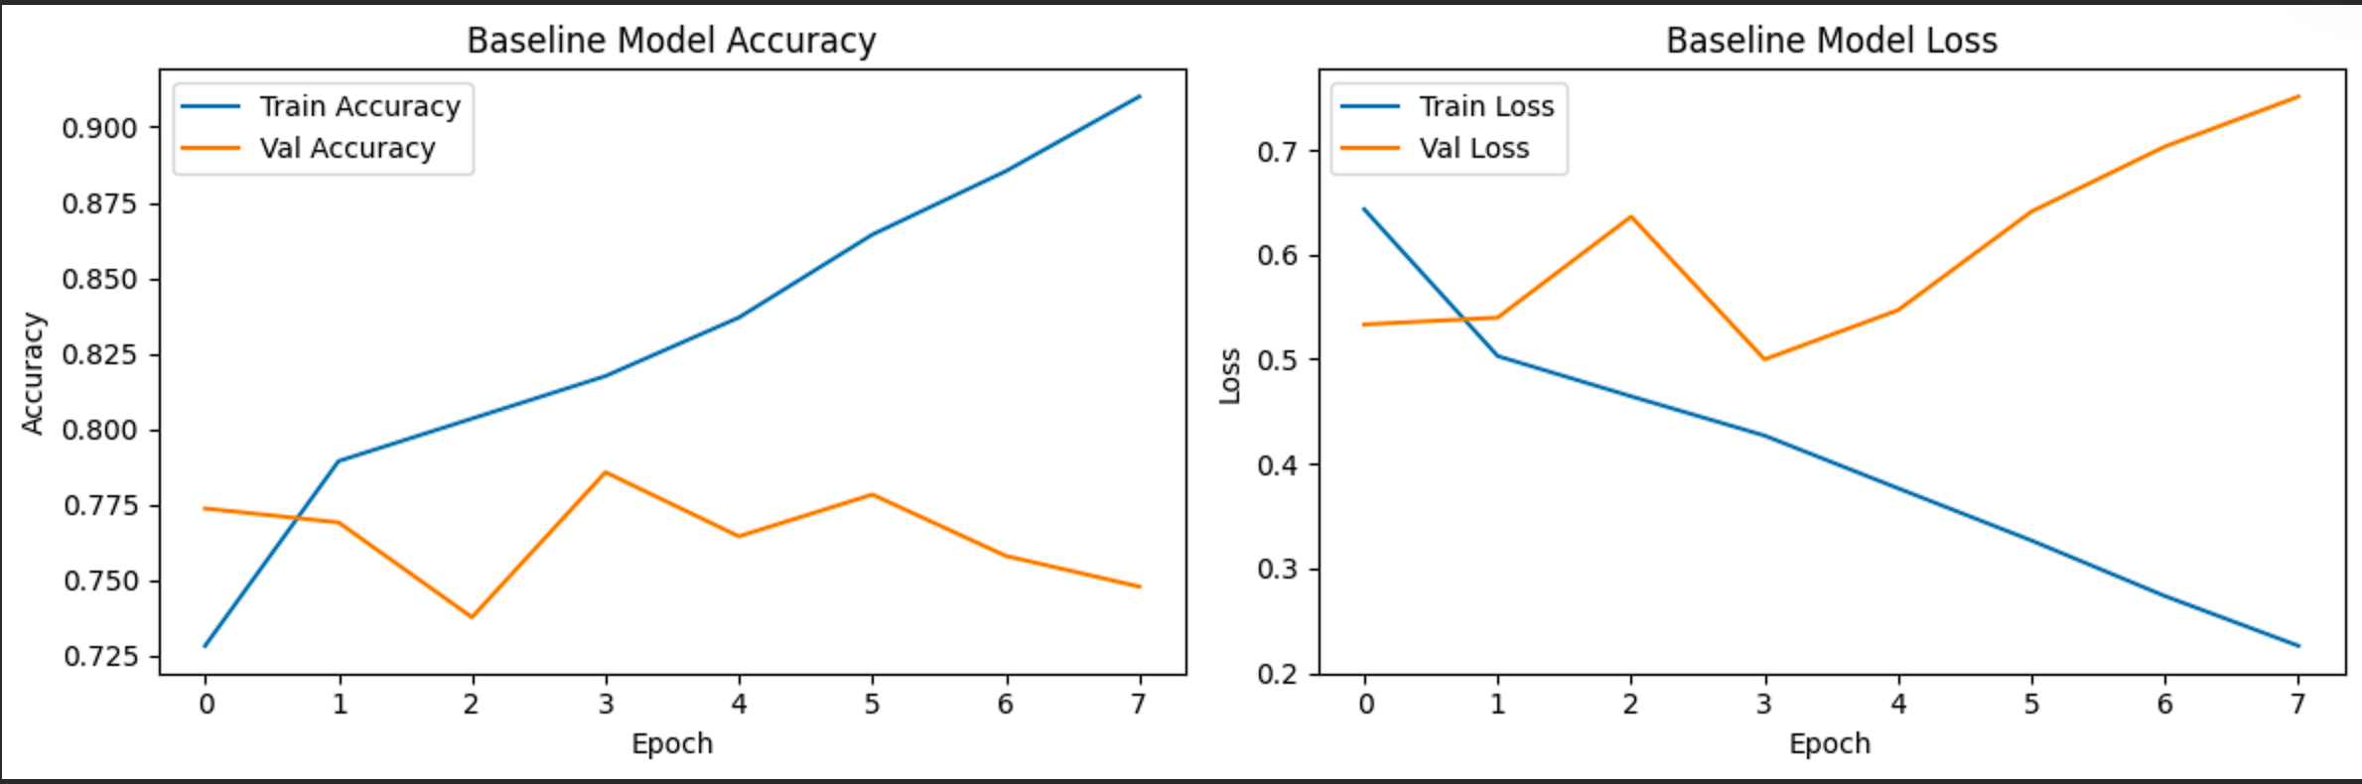
There are a few reasons this happened. First, the dataset is quite small for training a network from scratch. Second, the Flatten layer produces a very large number of parameters, which makes it easier for the model to memorise. Third, the Dropout rate of 0.2 is too low to stop this.
To fix this, the Flatten layer was replaced with GlobalAveragePooling2D, which reduces each feature map to a single number instead of flattening everything. This cuts down the number of parameters significantly and acts as a form of regularisation. Furthermore, the Dropout rate was increased to 0.4 and data augmentation was added to give the model more varied examples to learn from.

5. Question 4 Can Data Augmentation Be Performed?
Yes, data augmentation was one of the main improvements applied. It works by applying random transformations to images during training so that the model sees a different version of each image every epoch. This makes the model more robust without needing extra labelled data.
The following three augmentations were used:
- Random Horizontal Flip mirrors the image left to right, which simulates different patient positions.
- Random Rotation up to 10% slightly rotates the image, as can happen with different X-ray angles.
- Random Zoom up to 10% zooms slightly in or out, simulating variation in image framing.

These were chosen because they are clinically realistic. However, vertical flipping was not used because an upside-down chest X-ray does not make sense in a medical context and could confuse the model.

6. Question 5 What Layers Are in the Network and Can It Be Improved?

6.1 Baseline Network Layers
The baseline model has 11 layers in total. The first layer is a Rescaling layer which scales the pixel values from 0-255 down to 0-1 to make training more stable. After that there are three convolutional blocks, each made up of a Conv2D layer followed by a MaxPooling2D layer. The first Conv2D has 16 filters, the second and third both have 32 filters, all using a 3x3 kernel and ReLU activation. The MaxPooling2D layers reduce the size of the feature maps by taking the maximum value in each 2x2 region. After the three convolutional blocks, a Flatten layer converts all the feature maps into a single 1D vector. This is then passed into a Dense layer with 512 units and ReLU activation, followed by a Dropout layer with a rate of 0.2 which randomly switches off 20% of neurons during training to reduce overfitting. Finally, the output Dense layer has 3 units with Softmax activation, one for each class.

The convolutional layers detect features like edges and textures. MaxPooling reduces the spatial size of the feature maps. Flatten converts everything into a flat vector for the Dense layers, which make the final prediction. Several changes were made to improve this the Flatten layer was swapped for GlobalAveragePooling2D, BatchNormalization was added after each conv layer, the number of filters was increased to 32, 64, and 128, and Dropout was raised to 0.4.

6.2 Keras Tuner
The brief mentioned Keras Tuner as a tool worth looking into. Keras Tuner automatically searches through different combinations of hyperparameters things like the number of filters, the Dense layer size, the learning rate, and the Dropout rate and finds the combination that gives the best validation accuracy.
Instead of trying values manually one at a time, it uses strategies like Random Search or Bayesian Optimisation to find the best settings more efficiently. However, running a full Keras Tuner search on this dataset would take a very long time computationally. Therefore, the key hyperparameters were identified through manual experimentation instead. Keras Tuner remains a strong option for further improving the model in future work.

7. Question 6 Is Transfer Learning an Option?
Yes, transfer learning is a good option here. It involves taking a model that was already trained on a large dataset and using its learned weights as a starting point for a new task. This means the model does not have to learn everything from scratch, which is especially useful when the available dataset is small.
MobileNetV2 was used as the base model, pre-trained on ImageNet which has over 1.2 million images. It was chosen because it is lightweight and efficient, making it suitable for Collab. The original classification layers were removed and replaced with a new head for the three-class pneumonia task a GlobalAveragePooling2D layer, a Dense layer of 128 units, a Dropout layer, and a softmax output layer.

7.1 Phase 1 Frozen Layers
In the first phase, all MobileNetV2 layers were frozen so only the new classification head was trained. This gave a test accuracy of 73.68%, slightly below the baseline. The reason is that MobileNetV2 was trained on normal photos, not medical X-rays, so its features do not transfer perfectly to this domain.

7.2 Phase 2 Fine-Tuning
To improve this, the last 30 layers of MobileNetV2 were unfrozen and training continued with a very small learning rate of 0.00001. This allowed those layers to slowly adapt to X-ray images without destroying the useful features already learned from ImageNet.
Fine-tuning produced the best result overall a test accuracy of 76.43%, which is above the baseline of 75.06%. Moreover, the validation accuracy reached 78.39% during training. Therefore, fine-tuned transfer learning is the recommended approach for this task.

Model | Test Accuracy | Best Val Accuracy | Training Time
Baseline CNN | 75.06% | 77.38% | 5.09 min
Improved CNN (Aug + GAP) | 66.82% | 69.44% | 7.27 min
Transfer Learning (Frozen) | 73.68% | 75.25% | 5.11 min
Fine-tuned Transfer Learning | 76.43% | 78.39% | 8.74 min

8. Question 7 Precision, Recall and F1 Scores

8.1 What These Metrics Mean
Overall accuracy does not tell the full story for a medical classifier, so precision, recall and F1 score were calculated for each class separately.
Precision is how often the model is correct when it predicts a certain class. For example, if it predicted Bacterial 200 times and was right 148 times, the precision is 74%. However, a model could have high precision but still miss many sick patients by being too cautious.
Recall is how many of the actual cases the model managed to catch. If there were 184 real Bacterial cases and the model found 148 of them, the recall is 80%. In a medical setting, recall is the most important metric because missing a sick patient is far worse than a false alarm.
The F1 score combines both precision and recall into one number. It is useful when the dataset is imbalanced, as it punishes models that do well on one metric but badly on the other.

8.2 Results

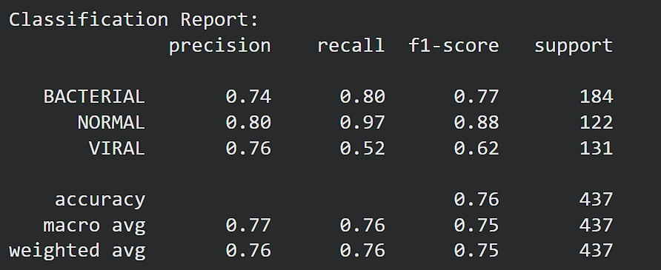

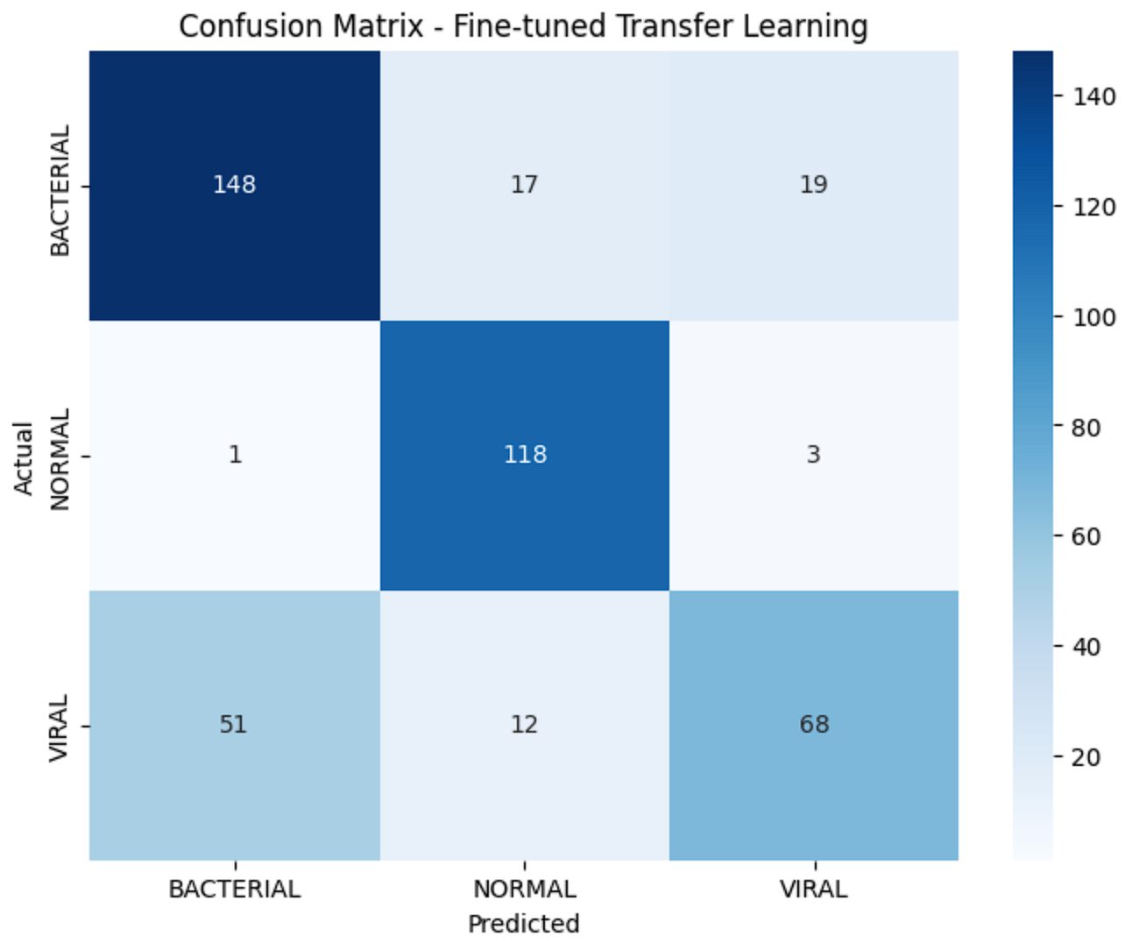

8.3 Which Metric Is Best?
Recall is the most important metric for this task. Missing a pneumonia patient could mean they do not get treatment, which is a serious risk. A false alarm would just lead to more tests, which is much less dangerous.
The NORMAL class performed the best with a recall of 0.97 the model correctly identified 97% of healthy patients. The BACTERIAL class had a recall of 0.80 which is reasonable. However, the VIRAL class was the weakest with a recall of only 0.52. This means the model missed about half of all viral pneumonia cases. Moreover, the confusion matrix shows that most of these missed Viral cases were predicted as Bacterial, which matters because the two conditions need different treatments.

9. Question 8 How Can the Model Be Better at Finding Sick Patients?
The main problem is the low recall for the VIRAL class at 0.52. There are several ways this could be improved.
The first option is to use class weights during training. This tells the model to care more about getting the Viral and Bacterial classes right by penalising it more when those are wrong. This directly pushes recall up for the harder classes.
The second option is to lower the classification threshold. By default the model picks the class with the highest probability. However, for medical use it may be better to flag a case as pneumonia even when the model is only moderately confident. This trades some precision for better recall, which is the right trade-off here.
The third option is to collect more Viral training data. The model struggles with Viral partly because there are fewer examples of it in the training set. Furthermore, targeted augmentation applied only to Viral images could help the model learn more about what makes viral pneumonia different from bacterial.
The fourth option is to try a larger pre-trained model such as EfficientNet or ResNet50, which have more capacity to pick up subtle visual differences between Viral and Bacterial. Moreover, training with a learning rate schedule where the learning rate gradually decreases over time could help the model find a better final solution.

10. Question 9 Can We See What the CNN Is Looking At? GradCAM
Yes, GradCAM was used to visualise what the model focuses on. GradCAM stands for Gradient-weighted Class Activation Mapping. It produces a heatmap overlaid on the input image where red areas are what the model focused on most and blue areas are what it mostly ignored.
It works by looking at the gradients in the last convolutional layer and using them to figure out which parts of the image had the most influence on the final prediction. This is useful because it shows whether the model is looking at the right parts of the image.
In this assignment, GradCAM was applied to the fine-tuned MobileNetV2 using its last convolutional layer. Six test images were used and the heatmaps were overlaid on the original X-rays.

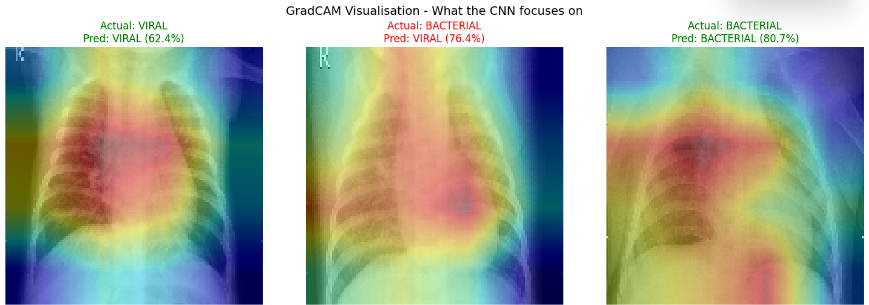
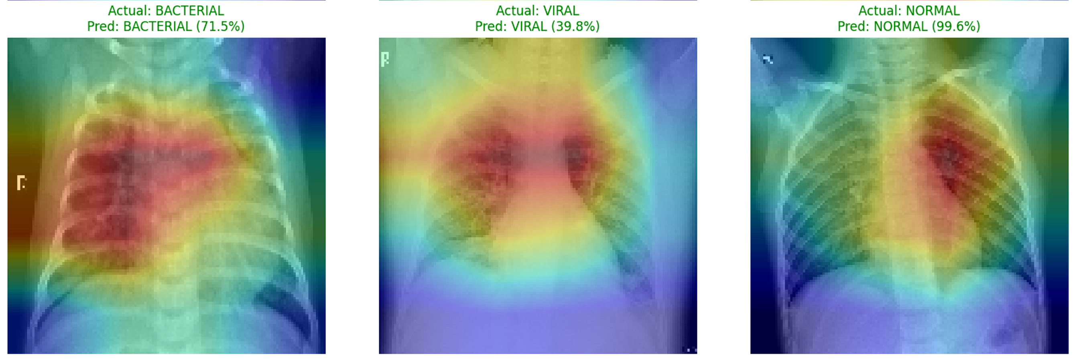

The results showed that for correctly classified images the model was focusing on the central lung tissue area, which is exactly where pneumonia shows up in X-rays. This is a good sign it means the model is learning the right things. However, for the misclassified Bacterial image that was predicted as Viral, the heatmap showed the model focusing on a slightly different area, which explains why it got it wrong.
Furthermore, the NORMAL case was predicted with 99.6% confidence and the heatmap showed broad activation across the lungs with no specific area standing out, which makes sense for a healthy patient. The VIRAL case with 39.8% confidence had a scattered and uncertain activation pattern, which matches its low recall score and shows the model is genuinely unsure about this class.

11. Question 10 Additional Research
Beyond what was directly asked in the brief, several extra techniques were looked into and applied.

11.1 BatchNormalization
BatchNormalization was added after each convolutional layer in the improved model. It normalises the output of each layer so the values stay in a consistent range during training. This makes training more stable and faster because each layer receives well-scaled input regardless of what the previous layers are doing. It contributed to more consistent training curves in the improved model.

11.2 Early Stopping
Early stopping was added to all improved models. It monitors the validation accuracy and stops training automatically if it does not improve for 4 epochs in a row. It also restores the best weights from training. This is a simple but effective way to prevent overfitting and avoid wasting time training past the best point.

11.3 Learning Rate
The learning rate controls how big each update to the model weights is. A rate that is too high causes the model to overshoot, while one that is too low makes training very slow. A learning rate of 0.001 was used for the frozen transfer learning phase, then reduced to 0.00001 for fine-tuning. The lower rate during fine-tuning is important because the pre-trained weights are already good, and large updates would damage them.

11.4 Increasing Filters
The number of filters in the convolutional layers was increased from 16 and 32 in the baseline to 32, 64, and 128 in the improved model. More filters give the model more capacity to detect a wider range of features at each level. Moreover, having more filters in the deeper layers is particularly useful because those layers are responsible for detecting higher-level patterns like shapes and structures relevant to pneumonia.

12. Conclusion
In conclusion, the assignment involved improving a deep learning model to classify chest X-ray images into Bacterial Pneumonia, Viral Pneumonia, and Normal. The baseline CNN started at 75.06% test accuracy but was clearly overfitting, with training accuracy reaching 91% while validation stayed at 74.79%.
The dataset was found to be imbalanced, with Bacterial having nearly double the images of the other classes. Data augmentation was applied to address this. GlobalAveragePooling2D replaced the Flatten layer to reduce overfitting. Transfer learning with MobileNetV2 was tested, and after fine-tuning the last 30 layers the best test accuracy of 76.43% was achieved.
Per-class results showed the NORMAL class performed best with 97% recall, while VIRAL was the weakest at only 52% recall. Recall was identified as the most important metric for this medical task. GradCAM confirmed the model was focusing on the correct lung regions. Furthermore, BatchNormalization, early stopping, and learning rate tuning were all applied as additional improvements. In future work, class weights, a larger model like EfficientNet, and a full Keras Tuner search could push performance further.

